Names: ___________________________________________________ Period: ____

___________________________________________________

**The Oregon Trail Computer Game Worksheet**

**Directions:** As you experience the Oregon Trail computer game with a partner complete the following questions. The game can be located online at (<http://www.virtualapple.org/oregontraildisk.html>).

1. Why were Americans traveling to the Oregon Country? (1 point)
2. What are some of the items that you purchased at the general store before setting out on the trail? (1 point)
3. What is a yoke? How many did you buy? (1 point)
4. Where are you starting off from? (1 point)
5. What month did you choose to start your trip? Why did you choose this particular month? (1 point)
6. Who did you pick to be when asked between the several people with different trades? Why did you pick this person? (1 point)
7. What was one geographical challenge you faced while on the trail? (1 point)
8. What was one biological challenge you faced while on the trail? (1 point)
9. Did anyone in your party die? If so how did they? (1 point)
10. What was the worst decision you made as a player of this game? How did this decision impact your progress? Answer in at least 2 complete sentences. (2 points)
11. How does this game simulate what early settlers went through trying to get to the Oregon Country? Answer in at least 2 complete sentences. (2 points)
12. If you were alive during this time period would you have risked your lives on the Oregon Trail to make it to the Oregon Country? Answer in at least 2 complete sentences. (2 points)

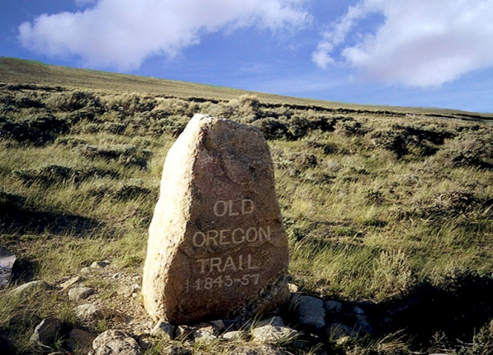 /15